Envision Next Business

Patient Appointment- 3
Imaging 6
Reporting 8
Captured Files 8
Study Metrics 8
Findings 9
Template 9
Report Show 9
Reporting Data Relationship Front-End 11

ENVISION NEXT is a cutting-edge endoscopic and ultrasound information system focusing on the patient. It allows doctors to easily take images or video sequences of medical operations while providing extensive reports on their findings in an easy-to-understand format for future reference.

The basic part of this software is-
- Patient Appointment
- Imaging
- Reporting

All the functions depend on these three basic parts.

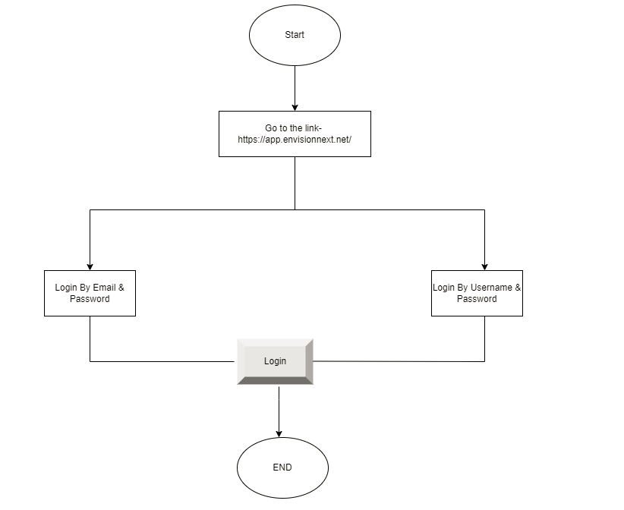

Patient Appointment-

After successful login to the system, the fundamental part is to register or create a new appointment for the patient. The new registration of the patient consists of basic patient information for completing the procedure of the registration. After completing the registration, the patient is ready for taking appointment. The user can select the patient's room, study, and appointment time in the appointment section. While creating the new appointment, the user can find the specific patient (already registered) from the search list. Then the procedure is the same as patient registration.
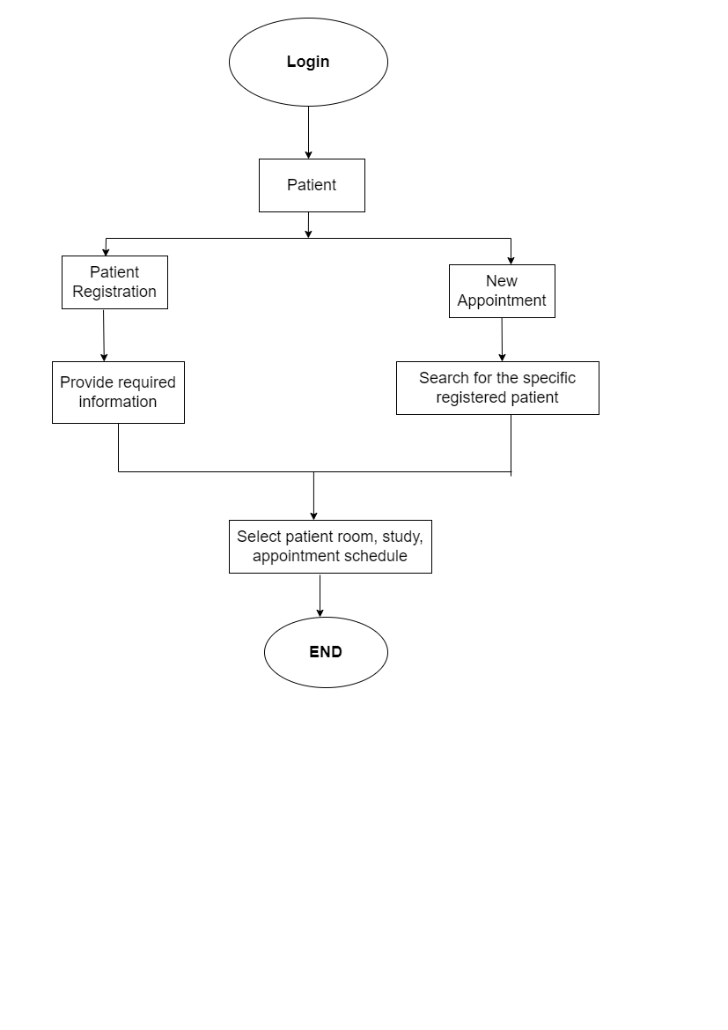

Imaging

The most important part of this software is Imaging. Imaging helps capture images based on the study to make efficient medical operations and makes user easier to create extensive reports on their findings. In Imaging, there are some core features.
- Live capture- When taking the image, the user can customize capture settings so that it will take before and after capturing live views.
- CROP X and CROP Y- The user can crop images through the X axis and Y axis.

The user can go to Reporting from Imaging. It will happen when the user select the process status to Success.

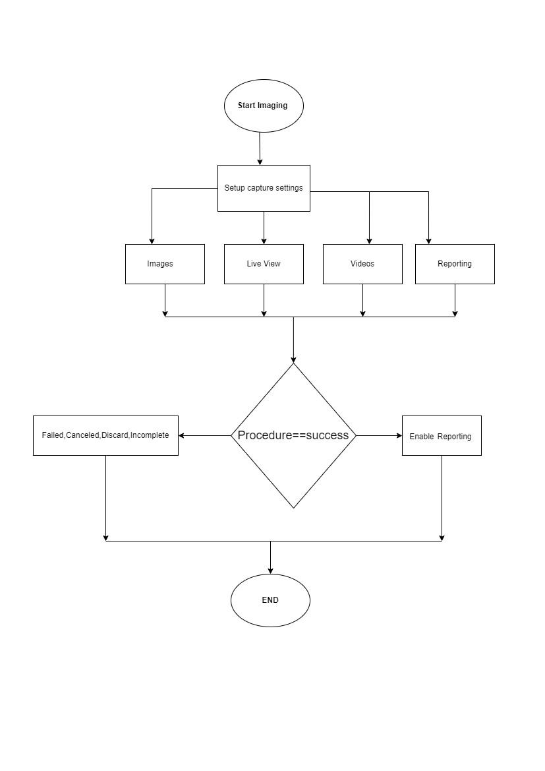

Reporting

The Reporting contains Captured Files, Study Metrics, and Findings. In Reporting, the user can add and select data according to the patient's situation.

Captured Files

The captured files contain patient imaging, live view, and videos, which the user will get from the Imaging. From the captured files, the user can easily maximize and sort images. They can also edit images from this section and add images from their devices. Finally, they can add the images to Reporting.

Study Metrics

After that, the user will get Study Metrics. This section includes Indication/Diagnosis, Sedation, Timing, and Team.

Indication/Diagnosis- In this section, the user can add Chief Complaint, Diagnosis, and Qualifier.

Sedation- Here, the user will get Sedation data. They can easily add data from this section.

Bowel Preparation- The user can add data in Bowel Preparation. They can add data according to the patient's situation.

Team- The user can add team members and can provide EPA in this section.

Timing- In the timing section, the user can add scope and edit procedural timing.

Findings

The user can add data in this part by checking the patient's situation. They can add multiple findings, regions, Findings Details, Interventions, and Complications.

Template
The user can add a template of their findings so that they can reuse the template for another similar type of patient.

Report Show
Finally, the user can view the report, print it, and download the report from here.

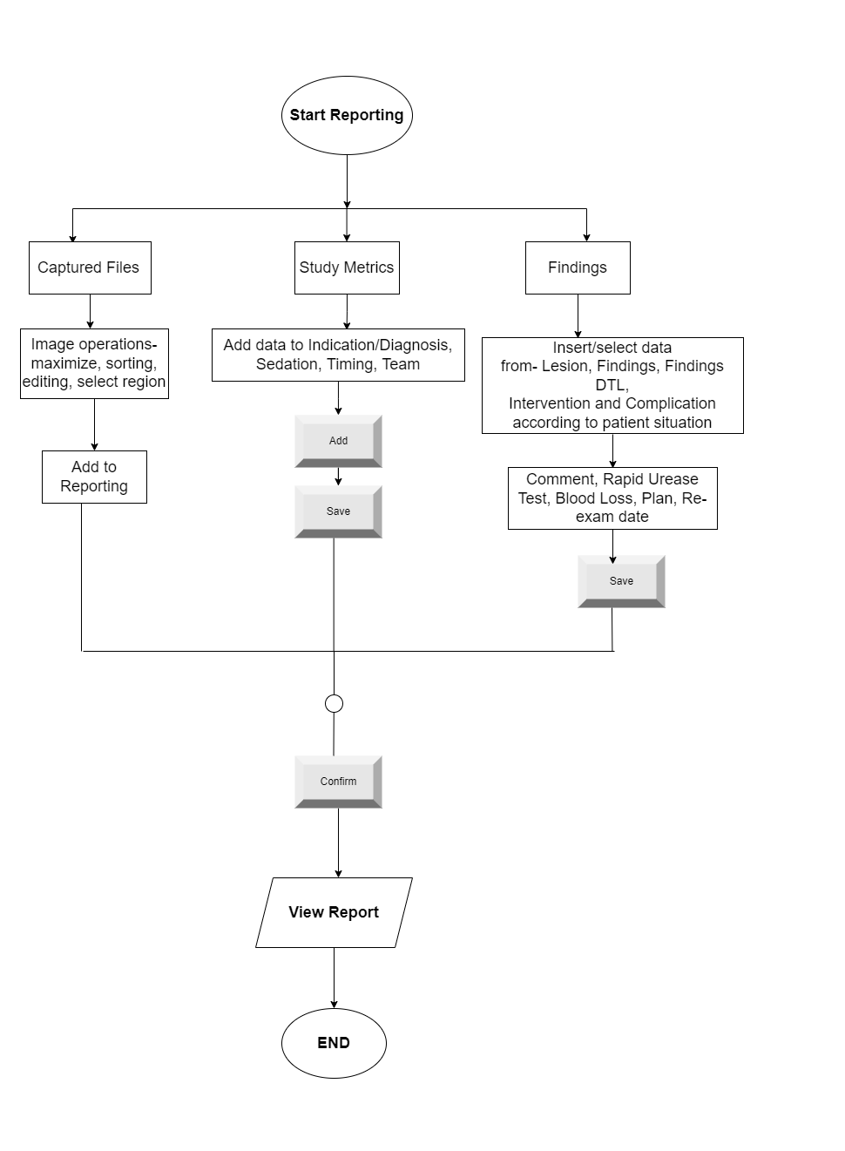

Reporting Data Relationship Front-End

Column Name | Remarks | Example
DISPLAY_NAME | To display in reporting box | 0-Ip
SINGULAR | To display in reporting editor | PARIS Classification -Protruded, pedunculated.
DELIMITER | Separator | , - / … etc.
MAX_VALUE | Input Max value [region range]
MIN_VALUE | Input Min value [region range]
INPUT_TYPE | Pop-up window input type like Text, Range, no, …etc.
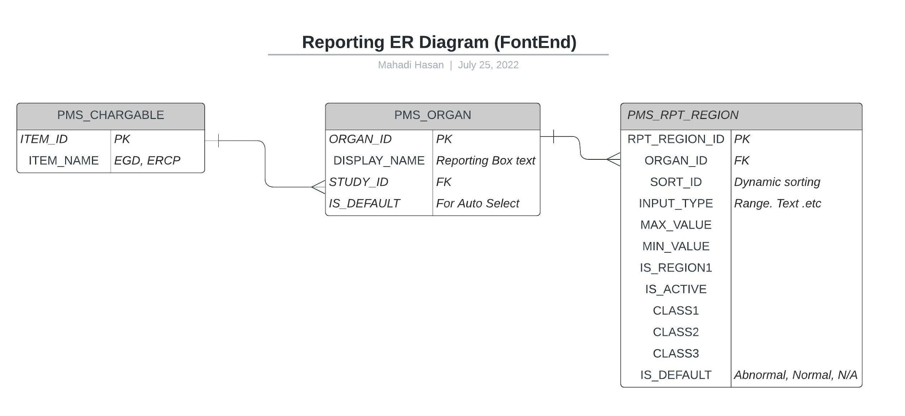
PMS_CHARGABLE table describes the study name. ex: COLONOSCOPY, EGD or ERCP … etc.
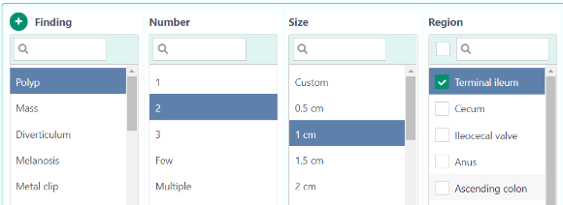
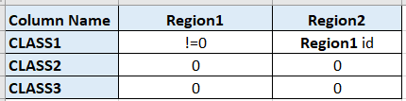
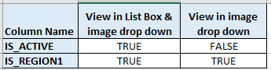
PMS_ORGAN table describes the organ name. ex: Anus, Colon
IS_DEFAULT column used for auto selection. Like image
PMS_RPT_REGION table describe region name, sub-region name
SORT_ID used for dynamic sorting
INPUT_TYPE described above
IS_DEFAULT used as a flag. When it is true, that means organ status is Normal, Abnormal or N/A
IS_REGION1 used as a flag. When IS_ACTIVE & IS_REGION1 both column true, then it will show region in List Box & image drop-down menu also. But when IS_ACTIVE is false & IS_REGION1 is true, then it will show the region in the image drop down menu only.
ClASS1, ClASS2, ClASS3 column used to identify Region1, Region2 & Region3. Region1 is called the main region, Region2 as the sub-region, and Region3 is Sub-Child-Region. Now in the present application we use region1 and region2.
Table Name | Column Name | Description | Example / Image
PMS_CHARGABLE  Describe the study name. |  |  | ex: COLONOSCOPY, EGD or ERCP … etc.
PMS_ORGAN  describe organ names. ex: Anus, Colon | IS_DEFAULT | column used for auto selection. As like image | 
PMS_RPT_REGION  table describe region name, sub-region name | SORT_ID
 | INPUT_TYPE | Pop-up window input type like Text, Range, no, …etc. | 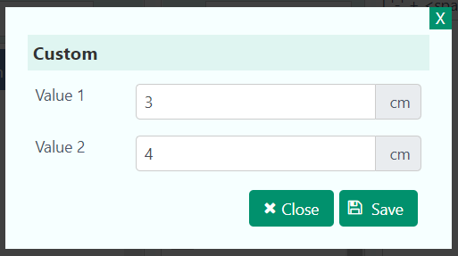
 | IS_DEFAULT | use as a flag. When it true that means organ status is Normal, Abnormal or N/A
 | IS_REGION1 | Use as a flag. When IS_ACTIVE & IS_REGION1 both column true then it will show region in List Box & image drop down menu also.  But when IS_ACTIVE is false & IS_REGION1 is true then it will show the region in the image drop down menu only. | 
 | ClASS1, ClASS2, ClASS3 | used to identify Region1, Region2 & Region3. Region1 is called the main region, Region2 as sub-region, Region3 as Sub-Child-Region. Now in the present application we use region1 and region2. | 

